OFFICIAL COORDINATION REQUEST FOR
NON-ROUTINE OPERATIONS AND MAINTENANCE

COORDINATION TITLE- 17 LMN 12 - Unit Priority after Return of Unit 2
COORDINATION DATE- 26 September 2017
PROJECT- Lower Monumental Dam
RESPONSE DATE- October 10, 2017

Description of the problem
At Lower Monumental, Unit 1 continues to be out of service for restoration as a Kaplan Unit and is not expected to return to service before spring of 2018. Unit 5 was forced out of service in January of 2017 and remains out of service. Unit 2 and 3 were forced out of service in August and September of this year, and have only recently returned to service. Both Units 2 and 3 have had the blades hydraulically blocked, leaving Units 4 and 6 as fully functioning Kaplan Units. Unit 3 was recently brought back online with the blades hydraulically fixed at the upper end of the 1% peak efficiency (~136 MW). Unit 2 went through a similar process but the blades were blocked at the lower end of 1% peak efficiency (~86 MW). According to the FPP, Unit 2 becomes the priority adult attraction unit when it returns to service. With Unit 2 running as the first priority unit, Unit 3 would be second according to the current plan. However, decreasing the amount of times Unit 3 is started and stopped is necessary to protect the temporary repair. Also, using a working Kaplan for the second priority unit would provide greater flexibility when it comes to matching required project output. The project is temporarily proposing the following unit priority until the end of adult passage season, 2017:

Unit 2, Unit 4, Unit 6, Unit 3*

*Last on, second to last off – If it is necessary to bring Unit 3 online, it would be beneficial to leave it on until flows drop low enough that only Unit 2 is needed.

Season | Duration | Unit Priority
September 26 – December 15  Fish Passage Season | Start Units | 2, 4, then 6, then 3 ª
September 26 – December 15  Fish Passage Season | Stop Units ^{b} | 4-6 any order, then 3, 2 ^{b}
December 16 – end of February  Winter Maintenance Period | Stop/Start Units | Any Order

a. Unit 3 has fixed Kaplan blades (non-adjustable) and operates in the upper 1% range. The priority order minimizes Unit 3 starts/stops and allows for the longest runtime once Unit 3 is started.
b. Stop units in reverse Start order, except run Unit 3 as long as BPA load request and required spill can be met.

Type of outage required

Impact on facility operation/ Impact on unit priority

Unit priority will be slightly different, shifting Unit 3 from second in priority to last on, last off. However, higher priority, Unit 2 is returning to service to aid adult passage.

Impact on forebay/tailwater operation

N/A

Impact on spill

N/A

Dates of impacts/repairs
Impacts would last from 26 September until the end of Fish Passage season on 30 November, 2017

Analysis of potential impacts to fish

Juvenile outmigration numbers are historically very low during this time period.

The 10 year average for adult fall Chinook passing Lower Monumental Dam from 26 September to 30 November is 6,760 (Figure 1). Fall Chinook numbers are expected to be lower than the 10 year average for 2017.

Figure 1: Adult Chinook Passage over Lower Monumental Dam 26 Sept – 30 Nov.

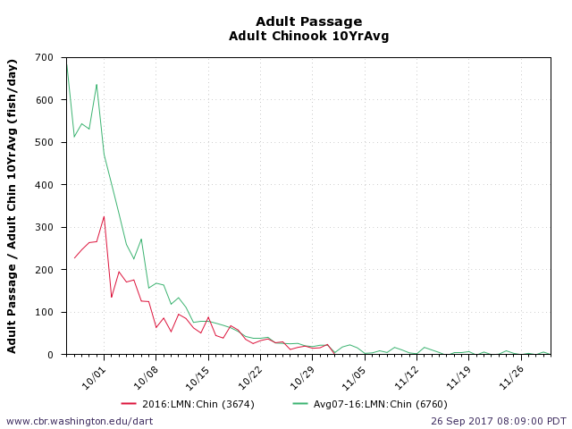

The 10 year average for adult steelhead passing Lower Monumental Dam from 26 September to 30 November is 79,290 (Figure 2). Steelhead numbers are expected to be much lower than the 10 year average for 2017.

Figure 2: Adult Steelhead Passage over Lower Monumental Dam 26 Sept – 30 Nov.
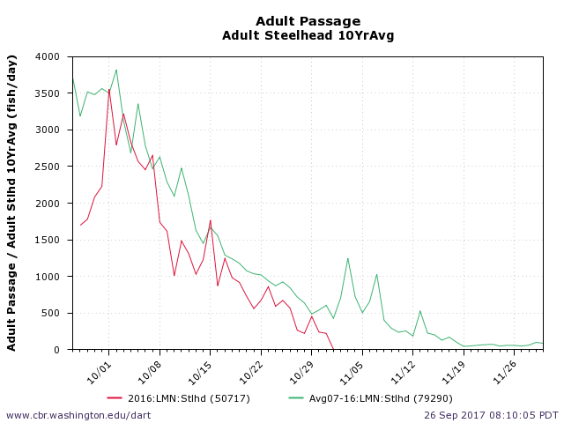

The 10 year average for adult Coho passing Lower Monumental Dam from 26 September to 30 November is 3,318 (Figure 3).

Figure 3: Coho Passage over Lower Monumental Dam 26 Sept – 30 Nov.
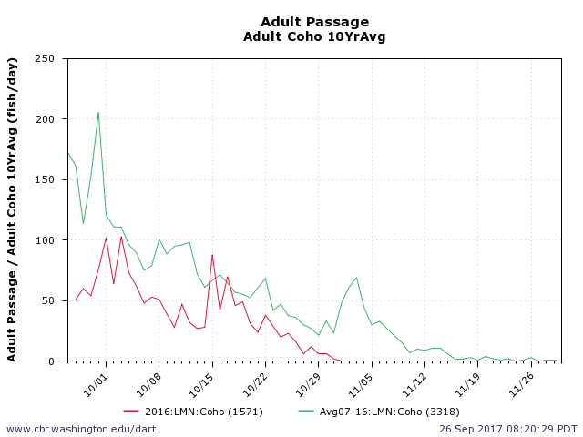

Summary statement - expected impacts on:

Downstream migrants
This change is expected to have very little impact on juvenile salmonids, as fish numbers are very low and the turbines will remain operating within 1% peak efficiency.

Upstream migrants (including Bull Trout)
This change will potentially benefit the adult fall Chinook and steelhead currently passing the project by moving the constant attraction flow closer to the north fish ladder entrance.

Comments from agencies

Final coordination results

After Action update (After action statement stating what the effect of the action was on listed species. This statement could simply state that the MOC analysis was correct and the action went as expected, or it could explain how the actual action changed the expected effect (e.g., you didn’t need to close that AWS valve after all, so there was no impact of the action). List any actual mortality noted as a result of the action)

Please email or call with questions or concerns.
Thank you,
Chuck

Chuck Barnes
Supervisory Fish Biologist
Lower Monumental Lock & Dam
(509) 282-7211
Charles.A.Barnes@usace.army.mil

